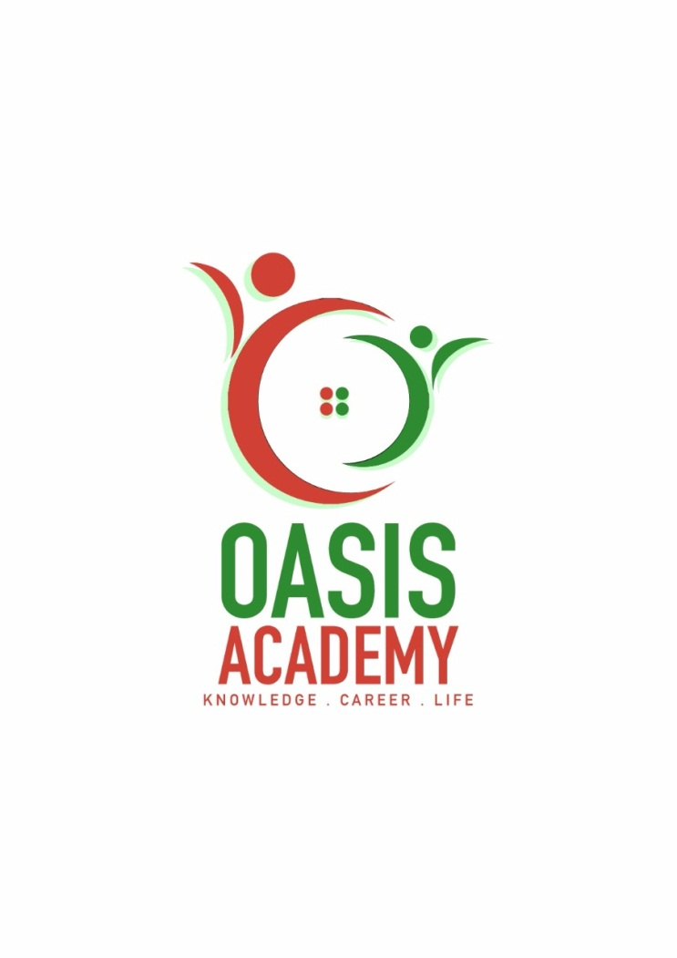

Name: Koh Chin Huat

Login ID: kohchinhuat@oasis-portal.com

Course title: Tourism and Hospitality

Subject Code: BHM04

Submitted date: 11-09-2017

**Table of Contents**

|  |  |  |
| --- | --- | --- |
| No | Details | Page |
| 1 | Executive Summary | 3 |
| 2 | Introduction | 4 |
| 3 | Assignment Question |  |
|  | Question 1 | 5-6 |
|  | Question 2 | 7-8 |
|  | Question 3 | 9 |
|  | Question 4 | 10 |
| 4 | Conclusion | 11 |
| 5 | References | 12-13 |

**Executive Summary**

In this assignment I learn about the Tourism and Hospitality. I able to define explain about the Tourism and Hospitality. In introduction part, I will explain about Tourism and Hospitality, and also giving an image to understanding. In the first part I learn about is the Tourism and Hospitality, and explain what i understanding about Hospitality industry. Second part I learn about is brief on different type of Tourism categories and define about Tourism. Third part I learn about is described the lodging accommodation and types of Hotel accommodation. Last part I learn about is explaining the Significance of Entertainment in this industry.

**Introduction**

In this assignment, Tourism and Hospitality is including lodging, travel and tourism, recreation, amusements, attractions, resorts, restaurants, and food & beverage service. Those are including in four career pathways in the Tourism and Hospitality pathway, the first is restaurants and food & beverage services, second is lodging, third is travel and tourism, and the last is recreation, amusements and attractions. The restaurant and food & beverage service pathways include workers performing a variety of tasks to maintain the operation of the diet and drinking water and to promote customer service. The lodging pathway includes occupations related to the operation of the accommodation facility and the care of the guests who use these facilities, through direct contact or to provide background services that enhance the experience of the guests. Travel and tourism pathway include a career focused on the development, research, packaging, promotion and provision of traveler experience. The recreation, amusements and attractions pathway include occupations related to the operation or maintenance of facilities, establishments and services for recreational or recreational facilities.

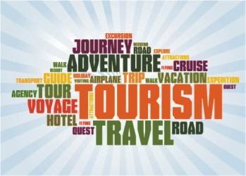

Figure 01 (4MDesigners)



Figure 02 (William Angliss Institute)

**Assignment Questions**

**Question 1**

Define the Tourism and Hospitality.

Explain your understanding about Hospitality industry

Tourism is a travel, recreation, religion, home business travel, usually limited in time. Although many people are tourists at some point in life, it is difficult to determine that tourism is actually. Travel refers to the activities of people who travel continuously to leisure, business or other uses other than the general environment. Travel is usually associated with transnational travel, but it may also refer to another location that travels to the same country. The World Tourism Organization defines visitors as "traveling to and staying in places outside their usual environment for not more than one consecutive year for leisure, business and other purposes. Tourism is a vibrant and competitive industry that needs to be able to continually adapt to the changing needs and aspirations of its clients because of customer satisfaction, security and enjoyment of the tourism business in particular.

Hospitality is usually defined as a warm, friendly and generous way to receive and deal with the quality and treatment of guests and strangers. What is missing in the dictionary definition is the feeling. Hospitality starts from the organization's leaders and their ideas. In order to evolve the operating environment, the real hospitality must come from their ideas. From there, will eventually change the minds of all employees. Any experienced person knows that it must be true, otherwise there will be no real impact, and will not continue.

For the customer or stranger to provide customer service industry. Hospitality management staff usually in the service environment as administrative or management duties, responsible for monitoring the hotel or restaurant and other institutions of operation and success. Hospitality and tourism diversification, including leisure parks, restaurants, recreational facilities, campsites, boarding houses, youth hostels and many other places. The overall goal of the Hospitality professional is to ensure that guests and customers enjoy a pleasant experience and can also be responsible for recruiting and training new employees; supervising offices and financial management; home economics, maintenance and security personnel; and marketing.

Hospitality industry professionals also allocate funds to set prices and ensure that the service standards are met. The general duties of the Hospitality industry professionals vary depending on the size of the business and the number of employees. In the larger business, there is usually a hierarchical general manager, assistant manager and supervisor, responsible for the implementation of its professional areas related to business tasks. In the smaller business, reception professionals perform these tasks directly. Sometimes hospitality professional positions are specialized. For example, some focus on managing the front desk while others can be responsible for conference services or financial management. If a receptionist is engaged in a professional position, he or she must have good communication skills and be able to work with colleagues in other business areas. Employers like applicants who have a bachelor's degree in business or hospitality, but a liberal arts degree and reception experience are also acceptable. Smaller institutions can accept applicants with a certificate or associate degree in hotel, hotel management or restaurant management.

**Question 2**

Brief on different type of Tourism categories.

Define Tourism.

Tourism is an effective way to see the world, experience the new culture, and see new friends at the same time. However, for many tourists, travel has done many other purposes, even with the joy of visiting the new location even without any relationship. This is why there are many different types of travel, explaining why visitors choose a particular destination, and what they are looking for to do there.

Perhaps the most common type of travel is the travel of most people traveling with tourism: entertainment. It is when people go to a place that is very different from their daily life to relax and play. The beaches, theme parks and campgrounds are often the most common places frequented by entertainers

If the purpose of visiting a place is to understand its history and culture, then this kind of tourism is called cultural tourism. Visitors can visit different landmarks in a particular country, or just choose to focus on one area. They can also participate in festivals and ceremonies to better understand the people, their beliefs and practices.

For those who want to look at wild animals or bathe in just the joy of nature tourists, natural tourism is the answer. Eco-tourism and natural tours are part of this tour. For example, bird watching is an activity that visitors like to do. What is this kind of tourism that marks its environmental responsibility, low impact, and favorable to the local community.

Today there are a lot of people in the company's fierce competition in the pressure, need to revive. So they travel, refresh their souls and spirits. This is called pleasure travel, usually including yoga workshops and detox leave. However, others can reduce stress by participating in specific movements known as sports tourism, where travelers are known for specific sports facilities. For example, skiing is a sporting tour. This category also includes those who experience the Olympic Games, the FIFA World Cup and other sports scene of the people.

Religious tourism is another way of traveling, where people go to religious places or places to follow the footsteps of the founders or attend religious ceremonies. For example, Catholics pilgrimage in the holy places to experience the path of Jesus.

Medical or health tourism is a relatively new tourism activities, the main focus of tourism is to improve people's health, physical fitness and physical fitness. For example, some countries promote physician and surgeon expertise in cosmetic surgery and invite foreigners to carry out liposuction, cosmetic surgery, nose lift and other forms of cosmetic surgery. Medical tourism also combines all aspects of leisure travel, the patient to leisure, from the program to recover.

Adventure tourism is another type of travel for those who want to do more than just access to regular tourist attractions. These trips involve challenging activities such as rock climbing, mountain climbing and wild drifting.

It should be noted that when visitors travel, there is no strict delineation. These travels often overlap, and it is not uncommon for travelers to experience more than one tour in a holiday.

Nowadays, people are more aware of the tourist destination and tourist attractions, money to spend money, need to get away from the daily life of tension. They take a break, refresh and relax, or may need some psychological and social needs. Travel service providers need to understand what drives a person to travel. Various purposes have been categorized, leading to different forms of tourism. Travel popular and the most basic form is leisure travel, which includes family tourism, cultural tourism, religious tourism, sports tourism. Business travel is also growing momentum.

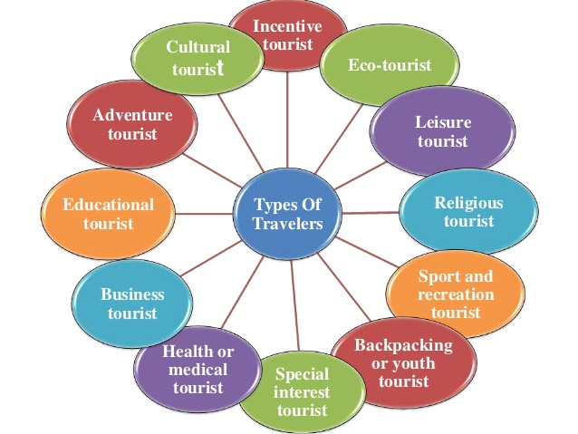

Figure 03 (LinkedIn Corporation) 2017

**Question 3**

Describe the lodging accommodation and types of Hotel accommodation.

The hotel offers an important role in trading companies, conferences and recreational facilities in most countries. In many areas, the hotel is an important attraction for tourists to attract consumers, and they are more willing to spend money than at home. The hotel industry is characterized by luxury hotels from luxury resorts and campsites. Accommodation is an absolutely extensive department of the hotel industry, including bed to breakfast business and hotel to other accommodation facilities. Customer service is indispensable for accommodation services. This is not all, efficiency, comfort, and perfect facilities are also the basis. A luxury resort should provide customers with privacy and exclusive services to cut it in the niche.

They are the three main types of hotels and accommodations, which is Lodging, Suite, and Resort. Lodging is when people travel from one place to another, they need a place to sleep, a sanctuary that protects them from the atrocities of nature. This led to a booking lodging and accommodation. Suite is in addition to the general stay, the hotel also offers deluxe suites. In general, suites are suitable for formal check-in, which is expensive compared to regular room service. Resort is the third category of accommodation that is popular among travelers is a resort. These make you close to nature and give you a necessary rest from your formal routines.

The following are some of the classification of hotels and accommodations; the hotel provides travelers with paid accommodation and other services for the guests. Depending on the size, location and facilities, the hotel is usually from one star to five stars but also graded and other rating plans are also used to classify hotels around the world. Boutique hotel usually decorated in a theme-independent style, the size of the boutique hotel intimate, focused on providing guests with high quality personalized experience. Timeshare is a vacation property with shared ownership and use rights. In addition, the choice of time-sharing rental can be an ideal choice for staying in hotel rooms, providing quality facilities and better value. Backpackers Hostel is a hotel for budget travelers, generally attracting young customers. The bedroom is dormitory system the bathroom is shared, although there may be a private bedroom. In addition to house prices, you can also provide light meals. A self-catering establishment may be mainly one of the other accommodation types, but also offers a special buffet facility. The unit should be equipped with a fully equipped kitchen to meet the maximum number (including refrigerators, stoves, cutlery, pottery, cookware, cleaning equipment). The kitchen should be exclusive to the guests, not the share.

**Question 4**

Explain the Significant of Entertainment in this industry

Entertainment category in the hotel industry, as it relates to the most important service. We are the buyer and recipient of all reception services. So, this sector of hospitality thrives for us and to entertain us. Entertainment is an important part of our travel today. If your travel experience lacks fun and entertainment, then you may not be able to fully enjoy your time. So, in order to successfully run the hotel business, it is important to have as many recreational activities as possible.

However, in terms of entertainment, some of the activities that can enhance the experience include: First Marinas: While attending the party, Marinas is one of the most popular places. Because you can get along with friends on a private yacht, you can dance, play games, and enjoy the best of everything in life. Second Sports and Games: Sports and games are the basic things people are looking for to travel. As a result, casinos, swimming pools and other similar activities are becoming an integral part of the hotel industry. Third cruise: In addition to the terminal, cruise service has become an important part of the hotel industry. Now, people like to spend the day in the clear sky through the blue ocean luxury boat. The fourth nightclub: who does not like to dance on your favorite song? We all do it all. That's why most of the senior hotels will have their nightclub service. The last one is the bar: sitting next to the table and friends drink a few drinks is always refreshing experience. This is why bars make an important part of the entertainment sector of the hospitality industry.

**Conclusion**

In this assignment I learn about the first thing is defined the Tourism and Hospitality and what I understanding about Hospitality industry. Tourism is a travel, recreation, religion, home business travel, usually limited in time. Travel refers to the activities of people who travel continuously to leisure, business or other uses other than the general environment. Travel is usually associated with transnational travel, but it may also refer to another location that travels to the same country. Hospitality is usually defined as a warm, friendly and generous way to receive and deal with the quality and treatment of guests and strangers. Hospitality starts from the organization's leaders and their ideas. In order to evolve the operating environment, the real hospitality must come from their ideas. The general duties of the Hospitality industry professionals vary depending on the size of the business and the number of employees. In the larger business, there is usually a hierarchical general manager, assistant manager and supervisor, responsible for the implementation of its professional areas related to business tasks. In the smaller business, reception professionals perform these tasks directly. Sometimes hospitality professional positions are specialized. Second thing I learn about is brief on different type of Tourism categories and defined about Tourism. Tourism is an effective way to see the world, experience the new culture, and see new friends at the same time. However, for many tourists, travel has done many other purposes, even with the joy of visiting the new location even without any relationship. Perhaps the most common type of travel is the travel of most people traveling with tourism: entertainment. It is when people go to a place that is very different from their daily life to relax and play. The beaches, theme parks and campgrounds are often the most common places frequented by entertainers. Nowadays, people are more aware of the tourist destination and tourist attractions, money to spend money, need to get away from the daily life of tension. Third thing I learn about is describe the lodging accommodation and types of Hotel accommodation. The hotel offers an important role in trading companies, conferences and recreational facilities in most countries. In many areas, the hotel is an important attraction for tourists to attract consumers, and they are more willing to spend money than at home. The hotel industry is characterized by luxury hotels from luxury resorts and campsites. The three main types of hotels and accommodations, which is Lodging, Suite, and Resort. Lodging is when people travel from one place to another, they need a place to sleep, a sanctuary that protects them from the atrocities of nature. This led to a booking lodging and accommodation. Suite is in addition to the general stay, the hotel also offers deluxe suites. In general, suites are suitable for formal check-in, which is expensive compared to regular room service. Resort is the third category of accommodation that is popular among travelers is a resort. These make you close to nature and give you a necessary rest from your formal routines. Last thing I learn about is explain the Significant of Entertainment in this industry. Entertainment is an important part of our travel today. If your travel experience lacks fun and entertainment, then you may not be able to fully enjoy your time. So, in order to successfully run the hotel business, it is important to have as many recreational activities as possible.

**References**

1. go2 Tourism HR Society (2017) (ONLINE) *WHAT IS TOURISM?.* RETRIVED FROM:

<https://www.go2hr.ca/bc-tourism-industry/what-tourism>

1. LinkedIn Corporation (2017) (ONLINE) *Creating customer loyalty in the travel and tourism industry*. RETRIVED FROM:

<https://www.slideshare.net/shraddhasamant98/travel-and-tourism-29721356/3>

1. GCSE Leisure and Tourism (ONLINE) *Key components of the tourism industry.* retrived from:

<http://www.leisureandtourism.net/?page_id=10>

1. Wikipedia (2017)(ONLINE) *Tourism*. RETRIVED FROM:

<https://en.wikipedia.org/wiki/Tourism>

1. 4MDesigners (ONLINE) *Tourism & Hospitality Management Course.* RETRIVED FROM:

<http://civilqscourses.com.pk/diploma/courses-tourism-hospitality-management-course-in-pakistan-training-pakistan-259.html>

1. William Angliss Institute (ONLINE) *Hospitality.* RETRVED FROM:

<https://www.angliss.edu.au/courses/hospitality>

1. Minnesota State CAREERwise Education (2017) (ONLINE) *Restaurants and Food and Beverage Services Pathway.* RETRIVED FROM:

<https://www.careerwise.mnscu.edu/careers/restaurants-food-beverage-pathway.html>

1. Minnesota State CAREERwise Education (2017) (ONLINE) *Restaurants and Food and Beverage Services Pathway.* RETRIVED FROM:
2. Minnesota State CAREERwise Education (2017) (ONLINE) *Lodging Pathway.* RETRIVED FROM:

<https://www.careerwise.mnscu.edu/careers/lodging-pathway.html>

1. Minnesota State CAREERwise Education (2017) (ONLINE) *Travel and Tourism Pathway.* RETRIVED FROM:

<https://www.careerwise.mnscu.edu/careers/travel-tourism-pathway.html>

1. Minnesota State CAREERwise Education (2017) (ONLINE) *Recreation, Amusements and Attractions Pathway.* RETRIVED FROM:

<https://www.careerwise.mnscu.edu/careers/recreation-amusements-pathway.html>

1. Nexxt, Inc (2001-2017) (ONLINE) *tourism & hospitality.* RETRVED FORM:

<https://www.beyond.com/tourism/defined>

1. GTI Media Asia (2017) (ONLINE) *What Is Hospitality?* RETRVED FORM:

<http://coursesmalaysia.com/article/what-is-hospitality.aspx>

1. LinkedIn Corporation (2017) (ONLINE) *What do the words hospitality and customer service mean to you?* RETRVED FORM:

<https://www.linkedin.com/pulse/20141016155813-131795743-what-do-the-words-hospitality-and-customer-service-mean-to-you>

1. William R. Marvin (2017) (ONLINE) *What Is Hospitality?* RETRVED FORM:

<http://www.aplaceofhospitality.com/whatisit.html>

1. Iresh Singh (2011) (ONLINE) *What is tourism and its types?* RETRVED FORM:

<http://www.indiastudychannel.com/resources/140791-What-is-tourism-and-its-types.aspx>

1. CareerIgniter.com. (2017) (ONLINE) *What Are The Different Types Of Tourism?* RETRVED FORM:

<http://www.careerigniter.com/questions/what-are-the-different-types-of-tourism/>

1. Luxury Accommodations (2011-2017) (ONLINE) *Understanding The Different Types Of Accommodation In Tourism* RETRVED FORM:

<http://www.luxuryaccommodationsblog.com/post/114961446726/different-types-accommodation-tourism>

1. States of Jersey (2017) (ONLINE) *Lodging accommodation.* RETRVED FORM:

<https://www.gov.je/Home/RentingBuying/OtherRentalOptions/Pages/LodgingHouseAdmin.aspx>

1. LinkedIn Corporation (2017) (ONLINE) *Lodging & Accommodation.* RETRVED FORM:

<https://www.slideshare.net/charliezabala7/lodging-accommodation>

1. SafariNow (ONLINE) *Accommodation Types.* RETRVED FORM:

<https://www.safarinow.com/cms/accommodation-types/irie.aspx>

1. UK Essays (2003-2017) (ONLINE) *Defining Types Of Hotel Accommodations.* RETRVED FORM:

<https://www.ukessays.com/essays/tourism/defining-different-types-of-hotel-accommodation-tourism-essay.php>

1. Global Hospitality Portal 2017) (ONLINE) *What are the Different Sectors of Hospitality Industry?* RETRVED FORM:

<https://www.soegjobs.com/2016/09/07/different-sectors-hospitality-industry/>

**The End**